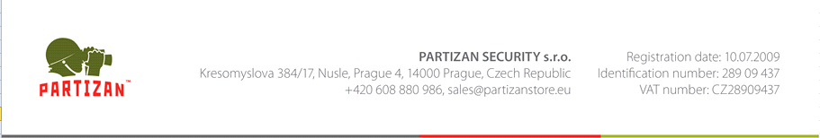

**RMA (Return Materials Authorization)**

**Request Form**

**Order number:**

**Contact email address:**

**Reason for return:**

* *Return within 14 days*
* *Wrong item received*
* *Warranty Repair*

|  |  |  |
| --- | --- | --- |
| **Product / Model name** | **Qty** | **Problem description** |
|  |  |  |
|  |  |  |
|  |  |  |